Dr. Stuart Freedman
13817 Village Mill Dr. ▪ Suite K ▪ Midlothian ▪ VA ▪ 23114
AdvancedStructuralRehab@gmail.com
(757) 725-0612

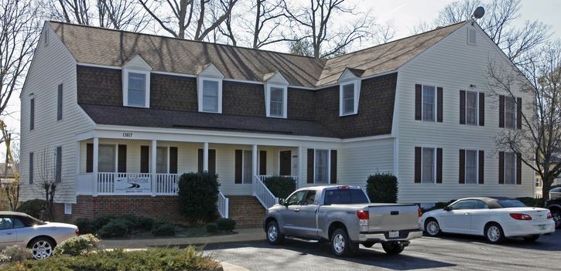

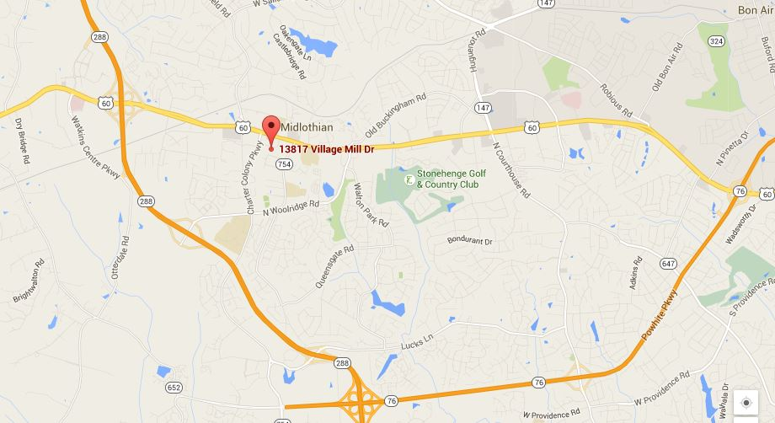

DIRECTIONS:

From I-288: Take the Midlothian Turnpike East exit. Travel east approximately 1 mile. After the 3rd traffic light (just past Charter Colony Rd.), turn right onto Village Mill Dr. You will pass Capital Ale House and Café Caturra, as well as a Wendy’s. Village Mill Dr. is just after the Wendy’s and before Firestone Complete Auto Care. Our building is located on the left – the third building from the end of the road.

From Rte 60 (Midlothian Turnpike) traveling west: Pass Midlothian Middle School on your left, go through two traffic lights – you will pass Sycamore Square Shopping Center on your right and Winfree Baptist Church on the corner of Rte 60 and Coalfield Blvd; turn left onto Village Mill Dr., just past Firestone and before Wendy’s. Our building is located on the left – the third building from the end of the road.

